Fullstack AgentCore Solution Template Charter Doc

Authors: David Kaleko Isaac Privitera

Background
AgentCore became generally available in October 2025 and is expected to be the go-to agentic platform for AWS. A large number of GenAIID engagements will be expected to leverage it effective immediately. There is a need to provide a shared, high quality starting technical asset to accelerate the initial build phase of such engagements to avoid people having to re-write the same code and perhaps make avoidable mistakes. GenAIID is uniquely positioned to drive best practices around agentic deployment on AgentCore not only within GenAIID, but across the entire AWS field.

Solution
To solve this problem, we propose the Fullstack AgentCore Solution Template (FAST). Similar to the “streamlit starter pack” but with AgentCore CDK and a React frontend, this asset will be planned and built by a cross-geo collaboration led by David Kaleko (NAMER) and Isaac Privitera (AWSI) with potential for more contributors from other geos. The target users are GenAIID developers building full stack applications for customer engagements. Ultimately this asset should be the starting point for all AgentCore engagements org-wide in the GenAIID.

Out of the box, developers will be able to clone the FAST repository, modify a simple configuration yaml file, and deploy an end to end security-approved full stack application (cdk) with an AgentCore backend and a react frontend. With all of the undifferentiated heavy lifting handled by FAST, developers will be able to quickly “vibe code” both the backend agent(s) as well as the frontend to customize the solution orders of magnitude faster than if they had started from scratch. They can use this to delight customers with baseline solutions on day 1 of an engagement, and rapidly add customer-specific features after that.

FAST will be a documentation heavy solution. Rather than supporting all possible configurations of agentic applications and requirements out-of-the-box, FAST will support basic starting points for common applications and will have extensive documentation (markdown files) describing how to build on the baseline with best practices so developers can use coding assistants to build exactly what they need. This documentation will enable coding assistants to e.g. “add semantic search over tools in AgentCore Gateway” or “implement async agents with Strands in AgentCore Runtime” according to best practices. FAST will not come pre-built with those features fully instrumented and integrated in the code base.

What FAST is NOT
- A fully instrumented full stack application covering every permutation of agentic use cases and requirements where users just change a config.yaml before deploying to get exactly what they want
- A collection of documentation or code snippets demonstrating best practices to help users start from scratch
FAST is in between these two things — a baseline full stack AgentCore application with tools and best practices and guidelines for developers to customize it with vibe coding.

Core Tenets
- Simplicity, simplicity, simplicity: The solution template should be just that, a solution template. It should be bare bones and without any frills, to keep it as easy to adopt as possible. Developers, who are often scientists and not SDEs, should start with the solution template to handle most of the undifferentiated heavy lifting components of building a full stack application then add onto it, not start with a bloated package and have to remove unnecessary features.
- Adaptability though Documentation: The solution template should be extremely well documented. While non-core features may not exist in the code base, approaches for implementing them should appear in markdown files in the repository. Users of FAST should instruct their coding assistants to prioritize following this documentation above all else.
- Vibe Friendly: The solution template should have READMEs and guides demonstrating how to use adapt it according to best practices with vibe coding. It should have opinions on recommended MCP servers and workflows for development. It should show developers that they don’t need to understand any React to modify the frontend.
- Opinionated Language and Framework: Python for the backend as it is the language everyone (including LLMs) is most comfortable with. React for the frontend to keep it as close to production grade as possible. CDK for the infrastructure as code for the modularity in typescript for typing benefits.
- Single threaded owner: The solution template should always have a single-threaded owner/team who maintains it and decides which features are important enough to add into code vs into documentation files (see Tenets #1 and #2).

Agent SDK Agnosticism
The solution template will ship with a working full stack application out of the box to solve a single demonstrative use case: multi turn chat with streaming responses where a single agent in AgentCore Runtime has access to tools through AgentCore Gateway. In order for FAST to support multiple agent SDKs (like Strands, LangGraph, CrewAI, etc), this use case will be implemented identically with each SDK, to demonstrate how to connect different SDKs to AgentCore infrastructure. These parallel implementations of the same use case are referred to as “agentic sdk patterns” in FAST.

Note this does not mean that FAST is only useful for multi turn chat use cases!

FAST Samples Repository
While FAST itself is a full stack application demonstrating solving a specific use case, it is designed to support any use case which leverages AgentCore. There is a separate "samples" repository of examples which FAST users can reference to help them vibe code the out-of-the-box FAST to a different use case. For example, there may be a "LangChain async deep research agent" example, or a "Strands swarm with agent identity restrictions" example etc.

Two versions of this repository exist. One is in code.aws.dev (gitlab) which is the single source of truth and is only accessible by members of ProServe. New samples should be pushed here as merge requests to take advantage of the gitlab Ultimate license perks. Additionally, there is a mirror of this repository in code.amazon.com (gitfarm) to grant access to everyone at Amazon outside of ProServe.

Architecture
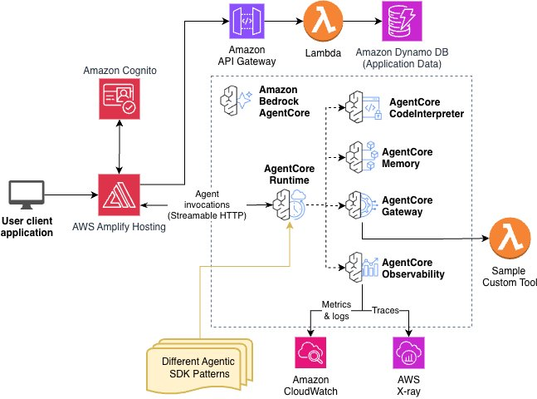

Long Term Plan
FAST has been open sourced into its own awslabs repository and long term ownership resides jointly between the original FAST developers and the Reusable Assets team.

FAQs
- How is this different from the Bedock AgentCore Starter Toolkit?
  - The Bedrock AgentCore Starter Toolkit is designed to “Deploy your local AI agent to Bedrock AgentCore with zero infrastructure”. The Fullstack AgentCore Solution Template (FAST) is somewhat the opposite — it is focused on supplying the infrastructure needed for engagements that use AgentCore to accelerate those engagements and produce nearly-production-ready solutions in days instead of weeks.
- How is this different from the APEX Delivery Agent?
  - The APEX Delivery Agent solves a similar challenge as FAST but in a different way. The APEX Delivery Agent offers a more fully automated approach. Their starting point is a requirement document, and they have a “planning agent” which plans the solution design and builds an application from scratch using “skills” created by the APEX team which encapsulate best practices and domain knowledge. In contrast, FAST starts with a working baseline full stack application that developers are responsible for customizing either manually or with coding assistants. FAST encapsulates best practices and domain knowledge with in-repository documentation (markdown files) and a separate FAST-samples repository. Both approaches aim to build fullstack applications.
  - In short, the APEX Delivery Agent and the Fullstack AgentCore Solution Template are exactly what their names describe. One is a delivery agent, one is a solution template.
- How can the code base be so simplistic when claims to support such a diverse array of agentic use cases?
  - The code base is simplistic intentionally. By keeping it simple with extensive documentation, this will allow FAST users (GenAIID scientists and engineers) to build up an application from a baseline. In this era of vibe coding it is faster to build a custom solution by building up from a simple, well documented baseline than to do so by tearing down from a monolith.
- I’ve just completed a customer engagement with FAST and I have some learnings. How do I contribute them back to FAST?
  - This is the beauty of having FAST be a documentation heavy solution. You can contribute your knowledge back into FAST for the immediate benefit of other users by simply creating a markdown file describing your learnings; no need to directly integrate any of your code into the repository. Alternatively, you can anonymize your entire application and post it to the FAST samples respository.
- Why does this use CDK instead of CloudFormation for the IaC portion?
  - The disadvantages of CDK are that some customers will prefer CFN to CDK, CDK requires bootstrapping of account and is more tedious to deploy, no one-click-deploy button is supported, etc. Advantages of CDK are that the IaC code is modular (as compared with a single template.yaml file in CFN), the code is python instead of yaml which is easier to read and understand, and the code is easier to collaborate on by multiple developers in parallel. Given that the end users of FAST are developers, we’ve chosen to start with CDK. Note, it is likely that CFN and Terraform forks of FAST will follow quickly regardless as the need arises.
- It looks like FAST’s default UI is a chatbot experience. Does FAST support non-chat use cases?
  - Yes it does! We chose to ship FAST with a chatbot experience as the simplest example. It is very easy to customize FAST to handle other use cases like document upload and analysis, research agents, etc. See the FAST samples repository to see ways in which others have customized FAST.

Resources
- FAST source code repository [OPEN SOURCE]
- FAST source code repository [INTERNAL]
- FAST samples repository [ProServe INTERNAL]
- FAST samples repository [Amazon INTERNAL]
- FAST Broadcast Channel
- FAST development Asana board
- FAST PCSR SIM (security)

